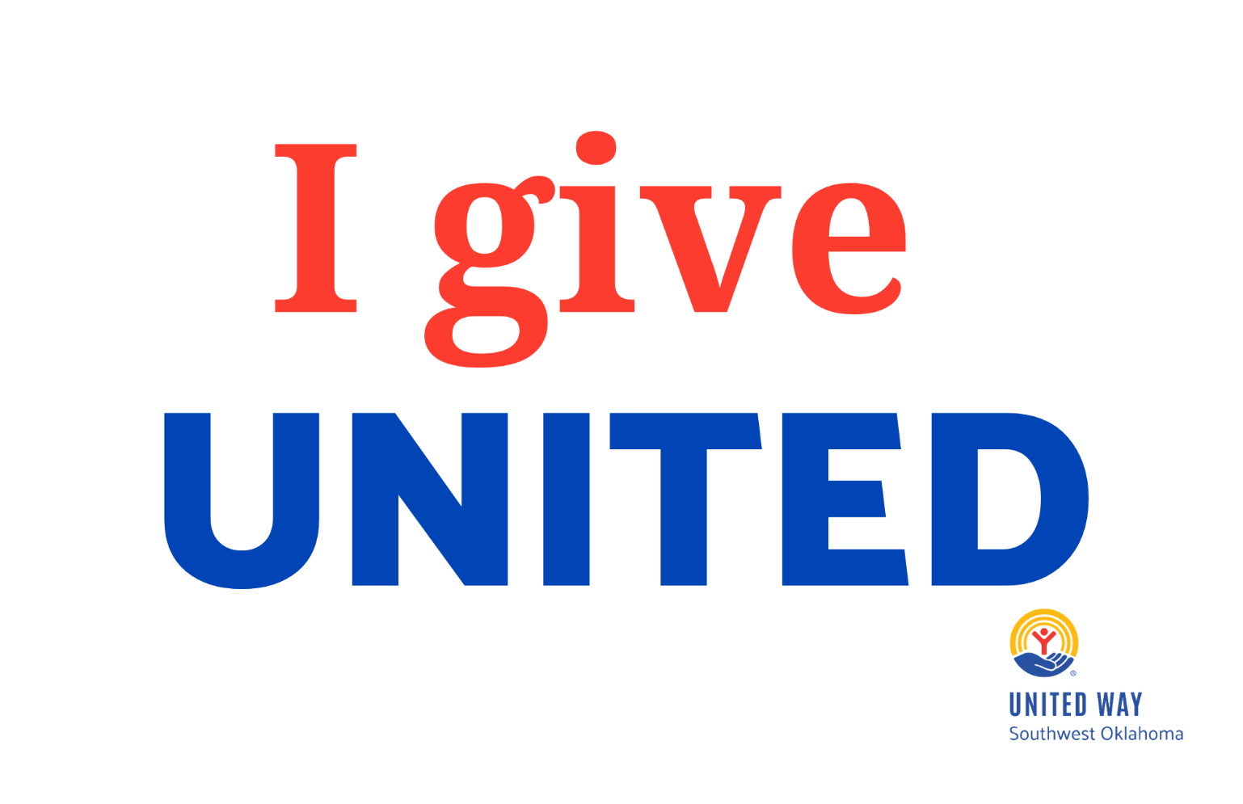

2026 Campaign Guide
for Workplace Campaigns

Congratulations on joining the United Way Annual Campaign team! This guide will help you have a successful campaign by giving you tips and tools to effectively communicate what UWSWOK does, the community benefits of donating to the Annual Campaign, and how to solicit donations for UWSWOK and its funded partners.

Table of Contents
UWSWOK WEBSITE 0
WHY GIVE UNITED? 1
2026 CAMPAIGN FACT SHEET 1
ECC CAMPAIGN CHECKLIST 1
HOST A KICKOFF RALLY 2
IDEAS TO BUILD A GREAT CAMPAIGN 3
WAYS TO DONATE 4
LEADERSHIP GIVING 4
UNITED WAY FUNDED PARTNERS 5
WHEN YOUR CAMPAIGN IS COMPLETE 5

UWSWOK WEBSITE

Check out the Campaign section of our website for more helpful information. It includes success stories, agency information, campaign ideas, and more.

www.uwswok.org/campaign

WHY GIVE UNITED?

When a community comes together, people find hope. Families find stability. Children find opportunity. And neighbors discover that they are not alone. That is the power of Giving United through the United Way of Southwest Oklahoma.

We believe our community is strongest when we work together. United Way brings nonprofits, businesses, community leaders, social services, and caring individuals to the same table to identify needs, connect resources, and create solutions that make a lasting difference. Gifts through your workplace campaign help strengthen the things every person and family needs to thrive: Education. Income Stability. Health. Basic Needs. Your gifts do more than support agencies and programs:

It helps connect a person to a resource.
It helps a family move toward stability.
It helps a child have greater opportunity.
It helps a community respond when needs change.

Your generosity gives United Way the ability to invest where the need is greatest, strengthen organizations doing important work, bring people together around shared challenges, and help turn caring into action. A single organization, business, or person cannot solve our community's challenges alone, but UNITED, we can accomplish more. When you give and volunteer through the United Way, you are investing in your neighbors, your community, and the future of Southwest Oklahoma.

  - WHO BENEFITS?
During 2025–2026, you helped make a difference for 106,366 people in Southwest Oklahoma. Together, we raised $1,021,300 to invest in local nonprofits working every day to meet our community’s most vital needs. Your generosity helped turn caring into action—and helped local organizations provide hope, resources, and opportunity to the people who needed them most.
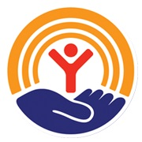
AGENCY VISITS

Our Funded Partners love to tell their stories. If you would like to have an agency visit your job site or visit one of our partner agencies. Please contact us to get it scheduled. Hear firsthand how your donations make a difference!

To schedule a tour, please contact our Community Engagement Manager,
Melissa Beck at (580) 355-0218 or melissa@uwswok.org

2026 CAMPAIGN FACT SHEET

COMMUNITY CAMPAIGN GOAL $1.2 MILLION
CAMPAIGN CHAIR: Laci Kavanagh

Funding stays local! – Money stays in Southwest Oklahoma to support our local community.
How funding is used is determined by volunteers like you. The Community Investment Committee is made up of community volunteers. They review all applications for funding and make funding recommendations.
16 funded partner agencies with more than 20 programs are supported through your donations.
Funded partner agencies are carefully selected and reviewed. Each provides critical health and human services for our community.
Local dollars mean local results, and we hope that you will consider contributing to this year’s campaign. The needs are greater, and the resources are less available.

ECC CAMPAIGN CHECKLIST

- Review your company’s giving history and past relationship with United Way.
- Encourage your CEO and/or leadership to be involved:
  - Complete his/her pledge card.
  - Pledge a corporate gift on behalf of the organization.
  - Promote incentives.
  - Send an email to all employees about the campaign.
  - Promote United Way during regularly scheduled staff meetings.
  - Participate in/or attend campaign meetings.
- Recruit a committee of co-workers to help you.
- Utilize the United Way staff.
- Set a challenging but realistic goal.
- Schedule specific start/end dates for your campaign to run and inform your co-workers of the deadline.
- Educate your co-workers
- Share what your business is doing on social media and tag the United Way
- Complete your campaign by collecting pledge cards and reporting your results to United Way staff.

- Thank your co-workers for their generosity! Send an email, hang up thank-you posters, and plan a celebration for a job well done!

HOST A KICKOFF RALLY

  - SAMPLE RALLY AGENDA
Use this agenda to help plan your campaign rally! Typically, each rally lasts about 15 to 30 minutes. Don’t have that much time? Your United Way staff can work with you to help plan a rally that works for your organization.

- 3 min - Welcome & United Way Endorsement CEO or ECC
- 5 min – “Why United Way?” Presentation UW Rep or ECC
- 6 min United Way Partner Spotlight UW Partner Rep
- 3 min Wrap Up (& Incentive Reminders) CEO or ECC
- 3 min Collect Pledges CC
(or remind them to pledge online)

  - SAMPLE RALLY SPEECH

Introduce yourself and thank everyone for attending.
- Give a brief overview of your organization’s United Way campaign. Include:
- Your organization’s campaign dates.
- Your organization’s fundraising goal.
- United Way facts/statistics using the United Way materials provided.
- Share your personal United Way story as a donor, volunteer, or as someone who has benefitted from their services
- Outline the incentives offered to the employees who donate
- E.g.: corporate match, corporate gift, prizes, luncheons, etc.
- Introduce the United Way speaker.
- Be sure to say THANK YOU!

  - TIPS FOR A SUCCESSFUL RALLY!

- Get them pumped by playing some music.
- Decorate the room in United Way colors.
- Serve food and/or snacks. Free food always gets people up and away from their desks.
- Pass out the United Way materials.
- Invite a speaker. Tell stories about being impacted by a United Way partner agency.
- Schedule a United Way staff member or Funded Partner to speak at the rally by contacting Melissa Beck (Melissa@uwswok.org)
- Offer fun door prizes to encourage attendance.
- Create in-office campaign competitions.
- Share all the incentives for participation.

IDEAS TO BUILD A GREAT CAMPAIGN

BREAKROOM RALLY - Have an employee rally that features a funded partner speaker, a United Way speaker, and the United Way Worldwide campaign video. Encourage your co-workers to attend and learn about United Way.
LUNCH - Who doesn’t love a meal they didn’t have to cook? Have a group luncheon where attendees pay to eat.
SNACK O’CLOCK - It’s 2 o’clock, and your afternoon munchies have kicked in. Employees can purchase trail mix, beef jerky, popcorn, or any of their favorite treats.
BOTTOMS UP - For $1, employees can purchase a beverage of their choice!
BBQ or CHILI COOK-OFF - A good, old-fashioned chili cook-off always brings in lots of attendance.
PHOTO BOOTH - Set up a photo booth with fun and interesting props and let the silly pictures begin!
JEANS DAY - Employees pay to wear jeans for one day or multiple days! (stickers available)
BREAKFAST - Nothing brightens a workplace like donuts or breakfast burritos! For $1, employees can purchase a breakfast treat and support UWSWOK.
SCAVENGER HUNT - Create a fun scavenger hunt around the office. Offer a prize to the winner!
UNITED WAY NEW EMPLOYEE PACKETS – Share the United Way New Employee Packet to introduce them to your organization’s culture of giving. Contact Melissa@UWSWOK.org for materials.
VIP PARKING – Auction/raffle off a prime parking space for a lucky winner to keep for a set amount of time.
TRIVIA CONTEST - Send out a daily email with several trivia questions about United Way, and the first to respond each day correctly wins a prize! Or have a lunchtime trivia competition in the break room.
COIN CYLINDER - Set up a fundraising cylinder at your business.
ART RAFFLE - Have a well-known artist as a friend/co-worker? Have them create a piece of art you can auction off or sell raffle tickets for.
PUMPKIN CARVING CONTEST - Allow employees to create a masterpiece out of a carved pumpkin. Everyone votes by donating money (each $1 counts as 1 vote), and the winner gets a prize!
COOK OFF - Have each employee make a signature dish that will beat everyone else’s! Use $1/1 vote to determine the winner!
PENNY WAR - Have departments compete by collecting change in jars!
PIE in the FACE - Recruit a volunteer to be pied if you reach your goal, or make it a contest: pie the person with the most votes $10 per vote.

WAYS TO DONATE

The ECC (or CEO) should be responsible for explaining their company’s options for giving (online donations, cash, check, credit card, payroll deduction, etc.). This can be done at a rally, in campaign literature, or one-on-one. Be sure your employees know when the donation deadline is and where to turn in their donations. You can even incentivize donations by awarding prizes to those who complete their forms by a certain date. If you have any questions about pledge cards or ways to donate, United Way staff can assist you!

CREDIT/DEBIT CARDS - Donors may give to United Way through any major credit or debit card. Those using credit/debit cards to donate can do so by:
- Completing a United Way pledge card, including the V code (last 3 digits) located on the back of the card and the billing address ZIP Code.
- Calling or stopping by the United Way office.
- Donating online by visiting www.uwswok.org and clicking on the “Donate” button.

PERSONAL/BUSINESS CHECKS - ALL checks should be made out to UNITED WAY OF SOUTHWEST OKLAHOMA.

CASH - Cash is always accepted! If a donor wishes to give cash, please complete a pledge card, which denotes their cash gift.

LEADERSHIP GIVING
Encourage donors to become a Leadership Donor and maximize their impact. Membership begins with an annual gift of $500 or more.

Leadership Giving Levels:
- Tocqueville Society is reserved for our most generous and community-minded contributors. Tocqueville members represent those who are willing to truly invest in the welfare of our community with an annual contribution of $10,000 or more to United Way.
- Diamond – annual contribution of $5,000 to $9,999
- Emerald – annual contribution of $2,500 to $4,999
- Ruby – annual contribution of $1,500 to $2,499
- Platinum – annual contribution of $1,000 to $1,499
- Gold – annual contribution of $500 to $999.

UNITED WAY FUNDED PARTNERS

CASA of Southwest Oklahoma
Catholic Charities
Center for Creative Living
Christian Family Counseling Center
Family Promise of Lawton
Girl Scouts of Western Oklahoma
Hearts that Care Volunteer Health Clinic
Lawton Food Bank
Legal Aid Services of Oklahoma
Marie Detty Youth and Family Service Center
MIGHT Community Development and Resource Center
Oklahoma Parkinson’s Alliance
Resource Navigation*
Success by 6
Scouting America, Last Frontier Council
The Salvation Army Corps, Lawton
Teen Court
VOAOK (Volunteers of America Oklahoma)
*In-house Program of UWSWOK

WHEN YOUR CAMPAIGN IS COMPLETE

IF YOUR COMPANY/ORGANIZATION USED PLEDGE FORMS PROVIDED BY UNITED WAY:
- Return the WHITE copy to the United Way in the campaign envelope.
- The YELLOW copy goes to the company’s payroll department.
- The PINK copy is given to the donor.

IF YOUR COMPANY/ORGANIZATION USED COMPANY-SPECIFIC OR ONLINE PLEDGE FORMS:
- Record the name and annual amount donated by each individual on a spreadsheet to submit to UWSWOK.

PLEASE RETURN TO UNITED WAY:
- Campaign Report Envelope - Ensure the envelope is completed, including total # employed, # pledging, and $ amounts
- Located on the top left of the envelope is a box where you can check if there are any designated pledges and if any donor qualifies to be a Leadership Donor.
- Make sure that all fundraisers are listed on the envelope in the area entitled Special Events.
- Please make sure that the person completing the envelope signs and seals it.
- Please mark billing instructions on the front of the envelope.
- The WHITE copies of the pledge form (if using the UW pledge form) or provide a spreadsheet with the name and annual amount donated by each individual (if done online)
- Cash and Checks (made out to United Way of Southwest Oklahoma)

