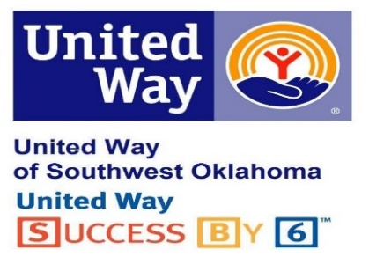

CAMPAIGNING TO POTENTIAL

full potential

“Full potential” is the amount that could be raised if all employees in an organization gave 1% of salary (salaried employees) or one hour’s pay per month (hourly employees). Based on research and evaluation by volunteers, eight-tenths of 1% (.008) of total annual payroll is the full potential for employee groups in the community.

Why think “potential”?

Everyone plans to achieve the best results possible from an employee campaign. In setting objectives for employee giving, a campaign volunteer often looks at past performance (what has been) rather than true potential, or what could be.

By looking only at past performance, you may underestimate your organization’s ability to raise funds. By applying the calculation, you may be surprised to learn how much potential actually exists at your organization.

FIGURING POTENTIAL

Begin by calculating:

Gross annual payroll $_____________ (times) X .008 = $_____________Full Potential

To set your campaign goal as a percent of your organization’s full potential, calculate the following:

Last year’s results = $______________ Last year’s results are what % of potential?

Last year’s results divided by full potential =_______________%

This year’s goal = $__________________

This year’s goal is what % of potential? _____________%

Example: XYZ Company has 100 employees. The average annual salary is $20,000. Their giving history is 2020 - $1350
2021 - $1700
2022 - $2000
2023 - $2400
Last year, they had 40 givers with an average gift of $60. Gross annual payroll is $2,000,000 X .008 = $16,000 Full Potential. Last year’s giving was 15% of Full Potential

